**Transform Your Balcony into a Bird Haven**

**As urban living spaces become more compact, many people wonder if they can still enjoy the benefits of feeding garden birds. CJ Wildlife offers a variety of products that allow you to feed garden birds in small spaces, supporting their population.**

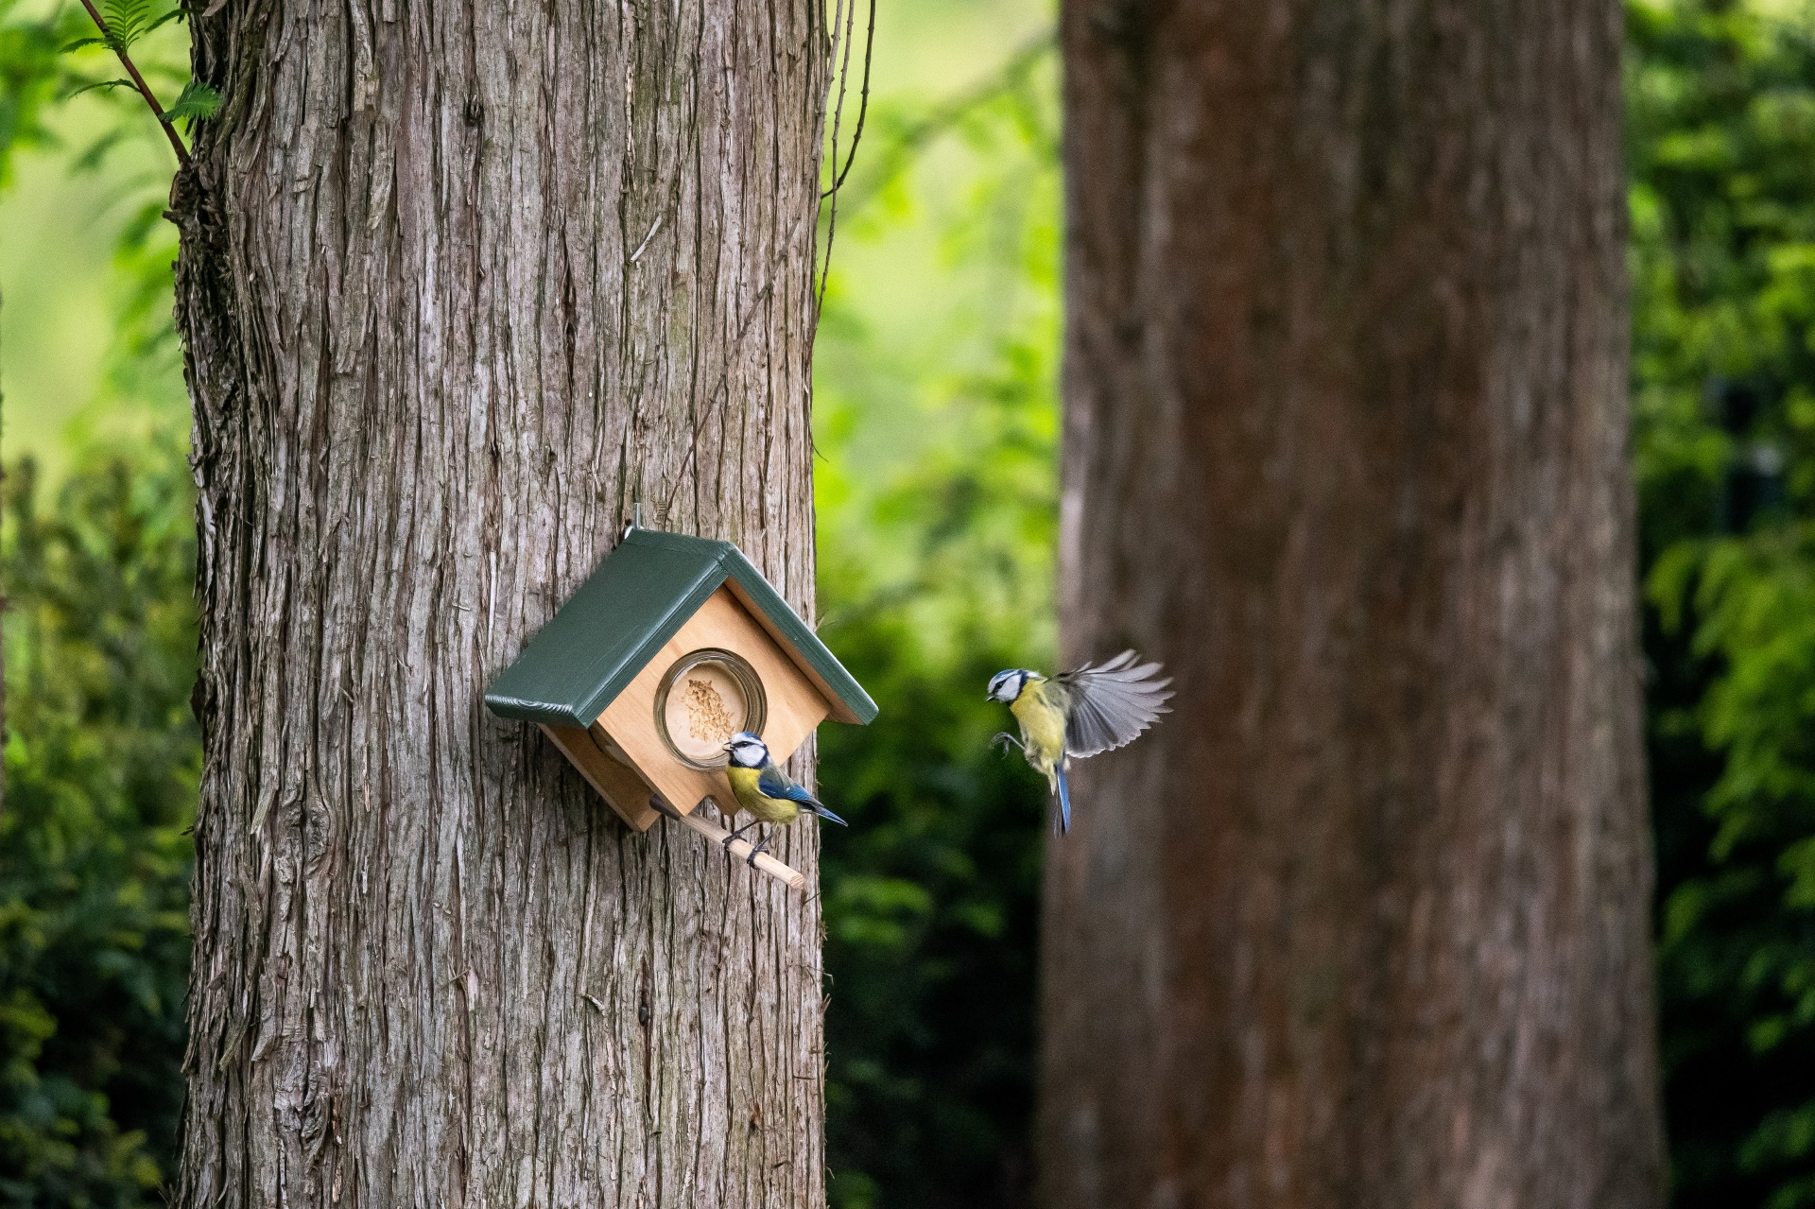

**The Benefits of Feeding Garden Birds**

Firstly, let’s delve into why you should feed your garden birds, as it has various benefits. By providing food and nesting boxes, you support your local wildlife and help sustain their population. Birds are natural pest controllers; attracting them to your space can reduce the number of insects and pests in your garden or balcony. Observing birds can be both educational and relaxing, offering a chance to learn about different species and their behaviours while providing a calming and stress-relieving activity. Birdwatching can be a delightful hobby for people of all ages.

Lastly, birds bring life and movement to your balcony or small garden, transforming it into a vibrant and dynamic space.

**5 Products below £ 25to get you started**

Transforming your balcony or small outdoor space into a bird haven is simple with our five specially selected products. Some of these items can even be applied to windows, making them perfect for offices or children’s rooms, allowing you to enjoy birds up close.

**Award-Winning Cork Peanut Butter Feeder**

CJ Wildlife’s Wall-Mounted

[Cork Peanut Butter Feeder](https://www.birdfood.co.uk/cork-bird-feeders)

,has recently been recognised with the prestigious GLEE New Product Award 2024. This innovative feeder features a unique weighted system that deters larger birds and squirrels, ensuring that smaller birds can feed undisturbed. It can be easily mounted to your wall.

**RRP:£14.99**

**National Trust Crete Window Feeder**

The National Trust

[Crete Window Feeder](https://www.birdfood.co.uk/crete-window-feeding-house)

is ideal for homes without a garden or with limited outside space. The feeder can be securely attached to a window with the two strong suction cups provided, allowing you to watch the birds feed from the comfort of your home. The transparent plastic ensures the birds are visible from every direction.

**RRP:£14.99**

**Lima Fat Ball Scoop & Feed**

Simply pick up a nutritious fat ball from your container using this handy scooping device and hang it from a branch or hook/bracket using the versatile combined handle and hanger.

[The Scoop & Feed](https://www.birdfood.co.uk/lima-fat-ball-scoop-and-feed)

can also be used to refill your fat ball feeder without any mess. Just hang it onto a branch or hook.

**RRP:£2.99**

**Seattle Predator Protection 32mm Nest Box**

This

[innovative nest box](https://www.birdfood.co.uk/seattle-32mm-predator-protection-nest-box)

has been specially designed to maximise the survival chances of chicks in the nest. It does this by making it far more difficult for predators such as cats, pine martens and squirrels to reach into the entrance hole and attack the young. This is made possible by the clever tunnel system and the right aligned entrance hole.

**RRP:£24.99**

**National Trust Build-Your-Own 32mm Nest Box**

The

[National Trust BYO Nest Box Kit](https://www.birdfood.co.uk/build-your-own-32mm-nest-box)

comes with everything you need to produce your very own nest box for generations of garden birds to come. Contains: Pre-cut wood sections, all screws, nails, washers and a hanger. Includes clear instructions. This 32mm hole nest box will be used by Great Tits, Pied Flycatchers, Tree Sparrows and House Sparrows.

**RRP:£14.99**

__________________________________________________________________

**Note to the Editor:**

Please get in touch with us, if you would like to test and review our wall-mounted Cork Peanut Butter feeder.

**Over: CJ Wildlife**

CJ Wildlife has been specialising in bird protection and biodiversity for over 35 years. We produce our products in-house and have our own production facilities across Europe. CJ Wildlife collaborates closely with esteemed green partners such as the National Trust and NABU in Germany. Our partners provide valuable advice on the development of innovative nest boxes and feeding systems, ensuring the preservation of biodiversity for our feathered friends.

**Newsroom**

View the full press release including more photos and videos in our Newsroom.

[View the full press release](https://cj-wildlife.presscloud.ai/press/transform-your-balcony-into-a-bird-haven)

[View all previous press releases](https://cj-wildlife.presscloud.ai)

**Contact information**

Naam: Nina Szynalski

E-mail: press@cjwildlife.com