**Increase the survival rate of your chicks with the Seattle Predator Protection Nestbox**

**Introducing the Seattle Predator Protection Nest Box, a revolutionary design from CJ Wildlife that offers unparalleled safety for nesting chicks. This isn&rsquo;t just any nest box; it&rsquo;s a fortress against predators like cats, pine martens, and squirrels. With up to 20% of nests falling prey to such attacks, the Seattle Nest Box is our answer to safeguarding the future of our feathered friends.**

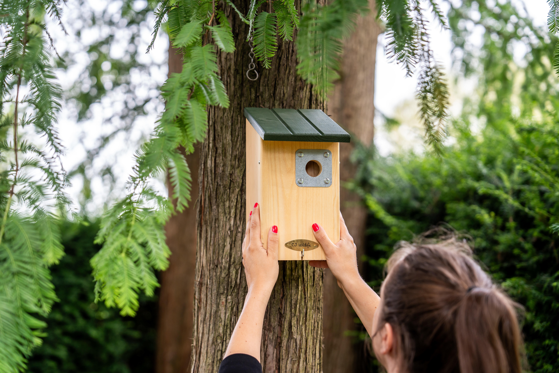

The nest box’s ingenious design features a

**tunnel system**

and an entrance hole aligned to the right, requiring two turns to access the main nest. This allows small birds, such as Great Tits and Pied Flycatchers, to navigate through effortlessly, while deterring larger predators who can’t manoeuvre their paws accordingly.

Equipped with a

**32mm entrance hole**

, it’s perfectly sized for Great Tits, Crested Tits, Nuthatches, and Tree Sparrows. Even smaller species like Blue Tits might find the enhanced security measures appealing enough to take up residence. To deter woodpeckers from tampering with the entrance, a robust metal plate fortifies the nest box.

Constructed from

**15mm thick pine**

, the Seattle provides essential insulation for vulnerable chicks and a cosy retreat for adult birds during the winter. The front panel is designed for convenience, opening up for straightforward cleaning post-breeding season, typically around October.

Measuring

**16 x 21.8 x 30.6 cm**

and weighing

**1.48 kg**

, the Seattle Nest Box offers ample space for chicks to thrive and grow, even with the addition of nesting materials brought in by parent birds. Crafted from

**FSC-certified wood**

and coated with eco-friendly paint, it’s as kind to the environment as it is to its avian occupants. A sturdy hanger is integrated into the back for secure mounting on walls, fences, or trees.

In a world where natural nesting sites are scarce, installing nest boxes like the Seattle, which mimic a bird’s natural nesting preferences, not only

**encourages breeding**

close to your home but also provides a sanctuary during the harsher months.

**Over: CJ Wildlife**

CJ Wildlife has been specialising in bird protection and biodiversity for over 35 years. We produce our products in-house and have our own production facilities across Europe. CJ Wildlife collaborates closely with esteemed green partners such as the National Trust and NABU in Germany. Our partners provide valuable advice on the development of innovative nest boxes and feeding systems, ensuring the preservation of biodiversity for our feathered friends.

**Newsroom**

View the full press release including more photos and videos in our Newsroom.

[View the full press release](https://cj-wildlife.presscloud.ai/press/increase-the-survival-rate-of-your-chicks-with-the-seattle-predator-protection-nestbox)

[View all previous press releases](https://cj-wildlife.presscloud.ai)

**Contact information**

Naam: Nina Szynalski

E-mail: press@cjwildlife.com